USB 2.0 Netlink Cable
User’s Manual

- Brief
- Product Features
- Installing USB 2.0 Netlink Cable Driver
- Sharing In Your Resource PC to PC
- Internet Connection Sharing In One Modem
- Uninstall USB 2.0 Netlink Cable Driver

1. Brief
The USB 2.0 netlink cable provides the easiest network cable without any network adapter. What’s more, the USB 2.0 netlink cable provides internet connection sharing function.
2. Product Features
You can upbuild a local area network (LAN) with two or more PCs by USB 2.0 netlink cable.
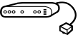
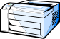
USB Hub
Netlink
Peripheral Sharing

3. Installing USB 2.0 netlink cable driver:
1. Please follow the steps as below to install the USB 2.0 netlink cable driver:
2. Power on your computer, make sure that the USB port enable and work properly.
3. Double click and open the folder ”USB 2.0 NETLINK CABLE”, double click “Setup.exe”.
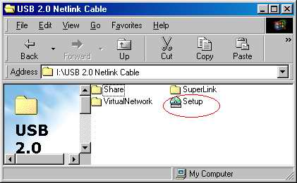
4. There will appear a dialog box as below, please choose the installation langue: 1. English 2. Japanese 3. Chinese(Traditional) 4. Chinese(Simplified) , please choose your language，then click “Next” to continue.
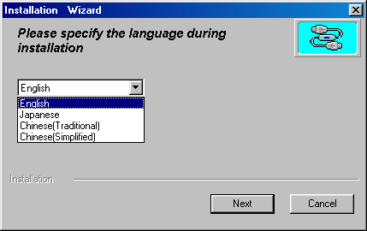

5. Please choose the installation type: 1. USB Super Link Adapter 2. USB Virtual Network Adapter, please choose 2. USB Virtual Network Adapter, then click ”Next” to continue.
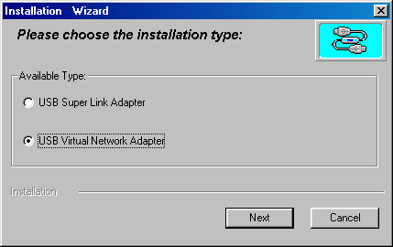
6. There will appear a dialog box as below, if you want to change directory, please click “change directory” to change the installation directory, please change “Next” to continue.

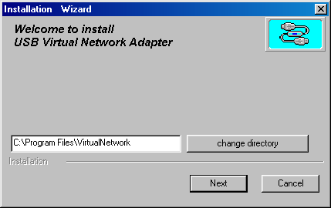
7. Windows will copy the needed driver files for the USB 2.0 netlink cable to your computer.
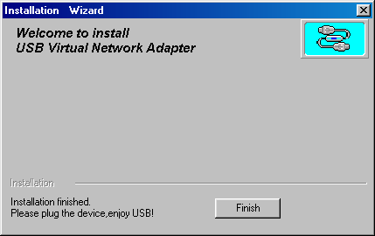

8. There will appear a dialog box as below, please click “OK” to restart your computer.
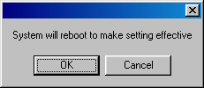
9. When you reboot your computer, please plug the USB 2.0 cable into your computer, windows will detect and install it automatically. If you can see “USB Virtual Network Adapter” in “System Properties”->“Device Manager”->“Network adapters”, it means you are successful.
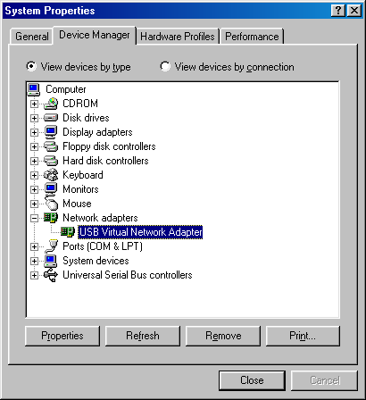

4. Sharing In Your Resource PC to PC:
- Please setup the different “Computer name” in “Identification” tag of”Network”.
- Please setup the same “Workgroup”.
- It is unnecessary to setup “Computer Description”.
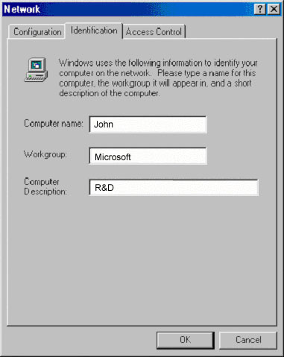
- In “Configuration” tag, you must install “Client for Microsoft Networks” and “NetBEUI”、“TCP / IP” protocol. You also must install “Files and printer sharing for Microsoft Networks”.
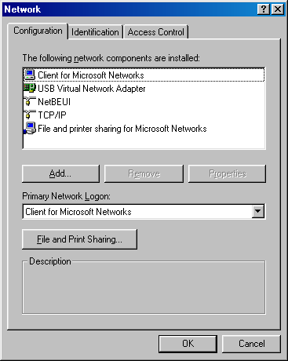
5. You must make “I want to be able to give others access to my files” and “I want to be able to allow others to print to my printer(s)” in ”File and print sharing” tag checked in order to see other computer s in” Network” Neighborhood”. At this time, you can see other computers in “Network Neighborhood”, and you can share in programs、files and peripheral devices through standard windows interface(for example: Windows Explorer or Network Neighborhood).
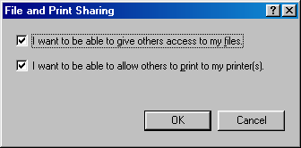
6. In “Primary Network Logon” item, select “Client for Microsoft Networks”.
7. Please click “OK”, a dialog box will appear as below, click “Yes”, and reboot your computer.
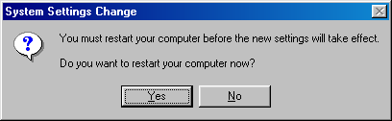
8. When you restart your computer, you will be prompted for a user name and a password to logon your network.
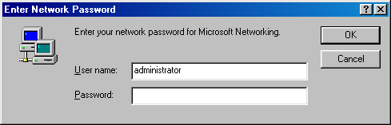
Please enter a user name and a password when you were prompted. This user name should be a unique name for your desktop or notebook; otherwise, you’ll cause a network conflict and make your network mal-function.
Notice: Entering a Password is optional. If you don’t enter your password when you were prompted for a user name and a password in the very first time, you can just click “OK” button at network logon screen to complete your login procedure. But remember, please don’t just press “ESC” or click “CANCEL” button to bypass this login screen, or your GeneLinkTM cable may not work correctly.
9. In “My Computer”, please right click”C” disk icon, a pop-up menu will appear, select “sharing…”.
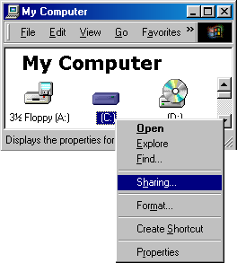
10. There will “( C:)Properties”, please select “Sharing”, input Share Name(for example: C), in “Access Type” ,you will have three types to choose : 1. Read-Only 2. Full 3. Depends on Password (for example: 2. Full).
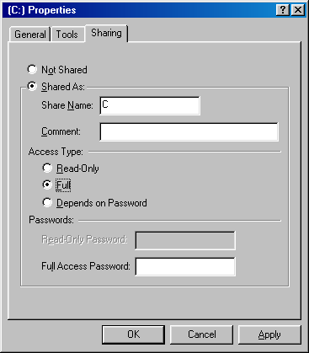
11. Please Click “OK”, there will appear a disk icon as below:
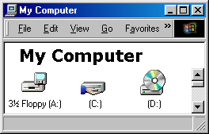
12. Please double click “Network”, there will appear a windows as below.
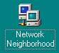
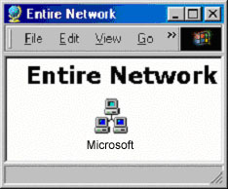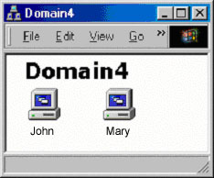
13. If you have already follow the above steps to set up sharing folders or disks, you can see your sharing files in any computer of the LAN.
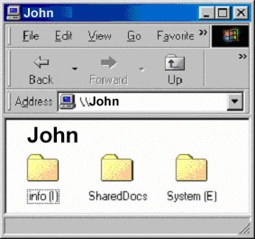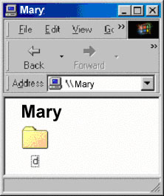
5. Internet Connection Sharing In One Modem
Please setup the computer with modem as server, install the sygate4.0 software in it. It is unnecessary to install sygate4.0 software in other computers.
IP Address:
Server: IP Address：192.168.111.1
Subnet Mask：255.255.255.0
Gateway：192.168.111.1（Server’s IP Address）
Other Computers:
IP Address：192.168.111.X (X : any number in 2 to 254)
Subnet Mask：255.255.255.0
Gateway：192.168.111.1（Server’s IP Address）
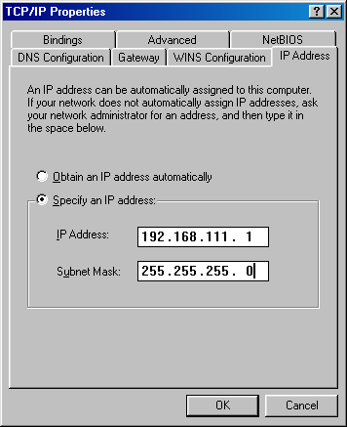
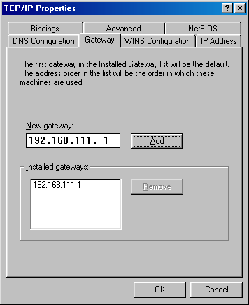
Now, you have already built a LAN with the USB 2.0 netlink cable. You can access internet with your family or friends together. Good luck!! :-)

6. Uninstall USB 2.0 Netlink Cable Driver

Please unplug the USB 2.0 netlink cable from the USB port of your computer!
1. Please follow the steps “Start”-> “Programs”->“USB Virtual Network”, click”Setup.exe” to start to uninstall the USB 2.0 netlink cable driver.
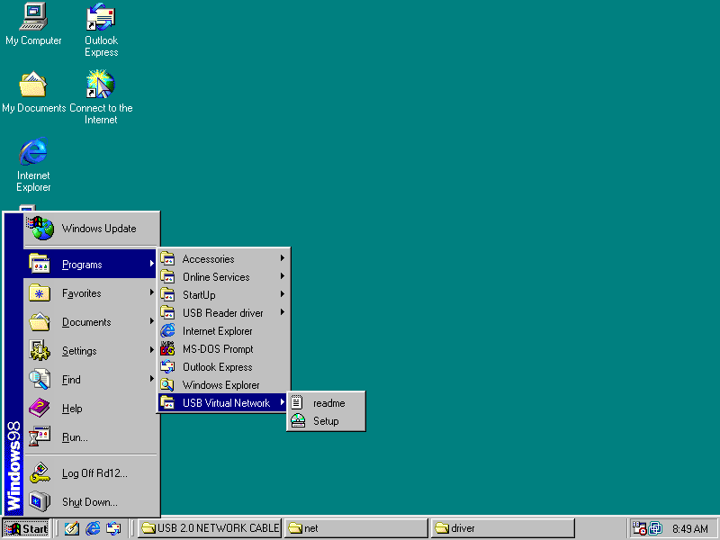
Click it
2. There will appear a dialog box as below, please specify the language during installation: 1. English 2. Japanese 3. Chinese(Traditional) 4. Chinese(Simplified) , please choose 3. Chinese(Traditional)，then click“Next”to continue.

3. Please choose the installation type: 1. USB Super Link Adapter 2. USB Virtual Network Adapter, please choose 1. USB Super Link Adapter, then click “Next” to continue.
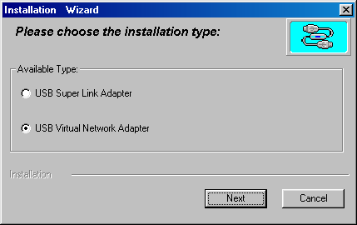
4. Please select “Only remove USB Virtual Network Adapter driver”, click “Next” to start to uninstall the USB 2.0 netlink cable driver.
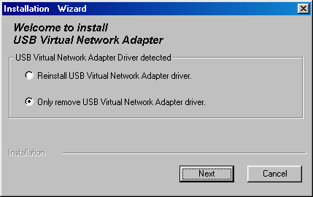
5. There will appear a dialog box as below, please click “Finish”.
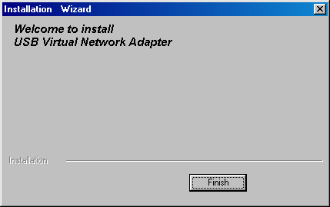
6. When finished, please click “OK” to reboot your computer.

